Nepal College of Information Technology
Assessment
Fall 2011
Program : BE ELX/IT/CE Time : 3 hrs
Semester : Fall (I) FM : 100
Subject : Engineering Mathematics-I PM : 50

- Candidates are requested to give their answer as far as practicable in their own words.
- The figure in the margin indicates the full marks
- Attempt ALL question

1. a) If a function f(x) is derivable at a point x=c. Show that f(x) is continuous at x=c. By taking suitable example show that the converse may not be true. 8
OR
State Leibnitz’s theorem for successive derivative of the product of two functions and use it to get nth derivative of the differential equation:
(1+x²) y₂+(2x-1)y₁=0
b) State and prove Lagrange’s mean value theorem. Use it to show that if 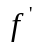(x)<0 in [a,b], function f(x) is decreasing in [a,b] 7
2. a) Evaluate 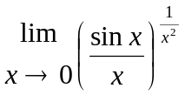 7
b) Define asymptotes of a curve. Find the asymptotes of
y³+x²y+2xy²-y+1=0 8
OR
Find the altitude of the right circular cone of maximum volume that can be inscribed in a sphere of radius a
3. Evaluate (any three) 15
i) 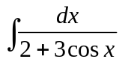
ii) 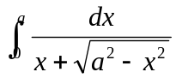
iii) 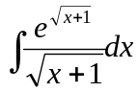
iv) 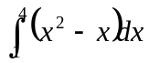 (by summation method)
4. a) Find the area of the portion of the circle x²+y²=4 cut off by the line x-2y=-2 in the first two quadrants. 7
OR
Show that the volume of the paraboloid formed by revolving the parabola y²=4ax and the line x=a about x-axis is 2a³.
b) Find the approximate area by using simpson’s and Trapezoidal rule for the region bounded by the curve y = x³, the x-axis, x=0, and x=2, with n=4 and compare with exact value. 8
5. a) Find the equation of the plane through the points (1,2,3) and (3,2,1) perpendicular to the plane 4x-y+2z=7 8
b) Show that 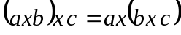 if and only if and are collinear vectors.
OR
Show that the points A,B,C, and D having position vectors are coplanar.
6. a) Define ellipse and derive its standard equation in the form of 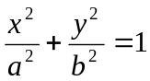 7
b) Find vertices and foci, line of symmetry and directrics of the parabolas.
i) y²+4x=8
ii) 4y²-8y+3x-2=0 4+4
7. Attempt all the questions: 5*2=10
a) integrate 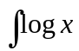
b) Find the projection of
c) Find the radius of curvature at (x,y) of y²=4ax
d) Find the domain and range of the function 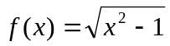
e) Find the eccentricity of the hyperbola 